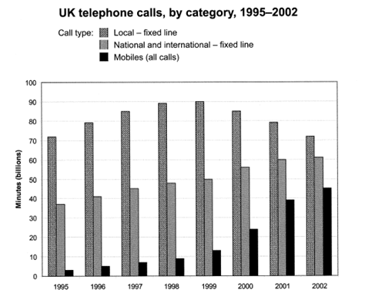

**The bar chart above illustrates** the total number of minutes in billions of telephone call in the UK over a seven-year period, which is divided into 3 categories. **As an overall trend, it is immediately apparent that** national and international-fixed line and mobiles **showed some growth during the period**. **In comparison**, local-fixed line **rose at the beginning but then experienced a downward trend.**

In 1995, national and international-fixed line started with the minutes of **around** 37 billion.

, and it kept climbing up from 1995 to 2002 **ending with 60 billion**. Mobiles **demonstrated a similar pattern.** It began with **roughly** 4 billion, which was a quite low figure. And **it witnessed a swift considerable rise** and it reached 45 billion **by the end of the time surveyed**.

**In the contrast,** **the situation was very different with regards to** local-fixed line. **In the beginning of the time shown**, the minutes of local-fixed line was **approximately** 72 billion, and **it hit a peak amounting to** 90 billion in 1999 but then **it touched the lowest point of about** 72 billion in 2002.